

**INDIAN INSTITUTE OF TECHNOLOGY, ROORKEE**

**PROJECT REPORT ON**

**SIC-XE ASSEMBLER DESIGN(supports Control Sections)**

**COURSE: System Software(CSN-252)**

**Student Details:**

**Name : Nagasamudram Karthik**

**Enroll No. :21114063**

**phone No. : 8688507943**

**Email Id :** [**n_karthik@cs.iitr.ac.in**](mailto:n_karthik@cs.iitr.ac.in)

**Guided By :**

**Manoj Mishra sir.**

**Submitted To:**

INDIAN INSTITUTE OF TECHNOLOGY, ROORKEE for AY-2022-2023

**Introduction:**

The aim of our project is to implement a two pass SIC-XE assembler.I designed this assembler which can support all kinds of formats . The assembler I designed also supports Program relocation as well as many machine independent assembler features such as literals, symbol defining statements, expressions, control section and program linking.

**Instruction formats supported by the assembler:**  
  
  
  
  
  
  
  
  
**Execution Flow:**

**Input:**

Assembler source program using the SIC-XE instruction set should be written in srcfile.txt

**Output:**

**Pass 1**:

In Pass-1, assembler generates a intermediate file for Pass-2

**Pass 2**:

Pass 2 will generate a listing file containing the input assembly code and address, object code of each instruction and also it will generate an object programincluding following type of record: H, D, R, T, M and E types

**Error:**

An error file is also generated displaying the errors in the assembly program (if any)

**Steps to run and Execute Assembler:**

**1)**First we need to give input in srcfile.txt

**2)** we have to compile “pass2.cpp” file by “g++ pass2.cpp -o pass2.exe” command

3)so by running pass2.cpp file pass1 method will be called which was implemented in pass1.cpp file after running this pass1 function intermediate file will be generated which is given input to pass2 to get object code and object Program.

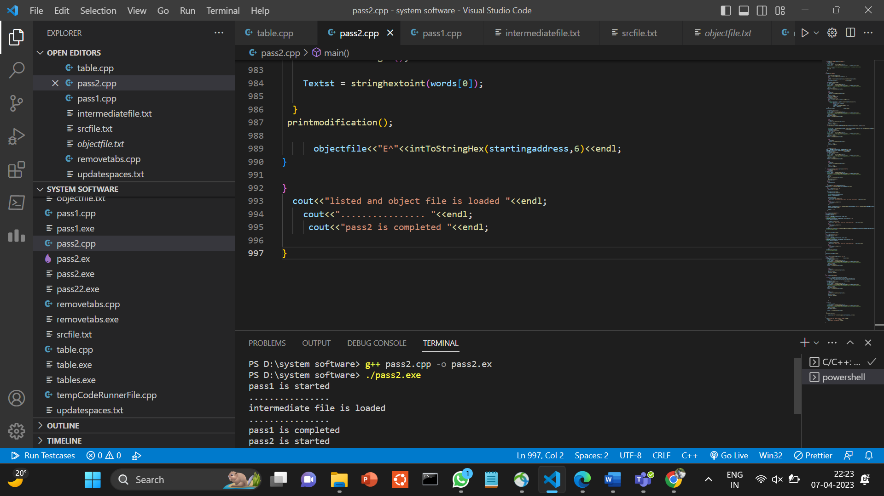

Input:  
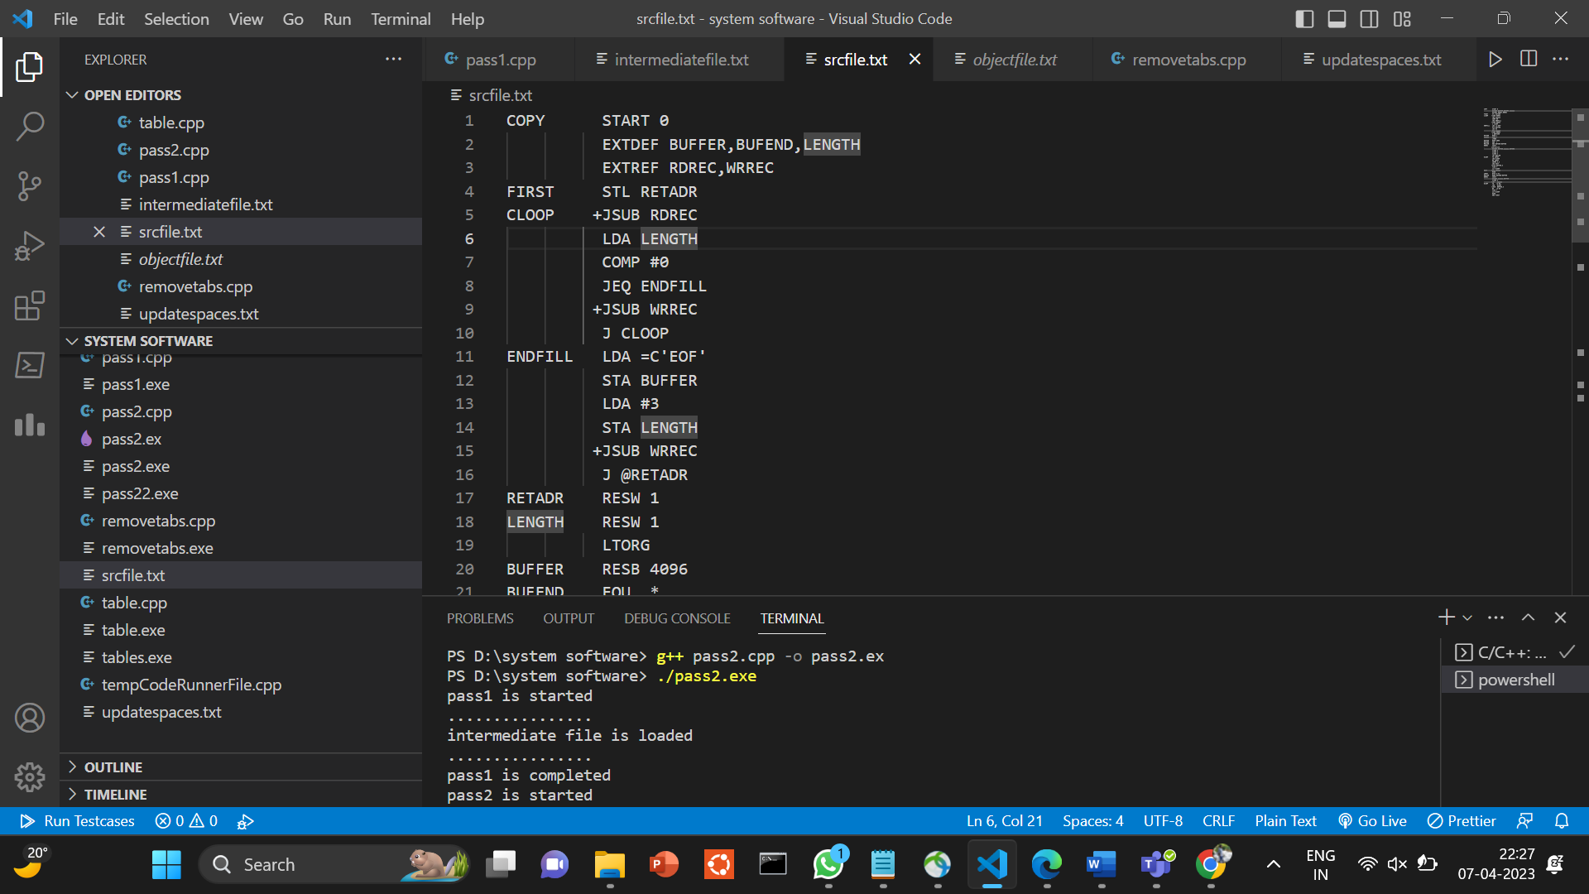  
  
  
  
  
  
Preprocess Step(to remove tabs in src file this function will be atomatically called whenever we ran the pass2.cpp file.this updated one will be loaded into updatespaces.txt file.  
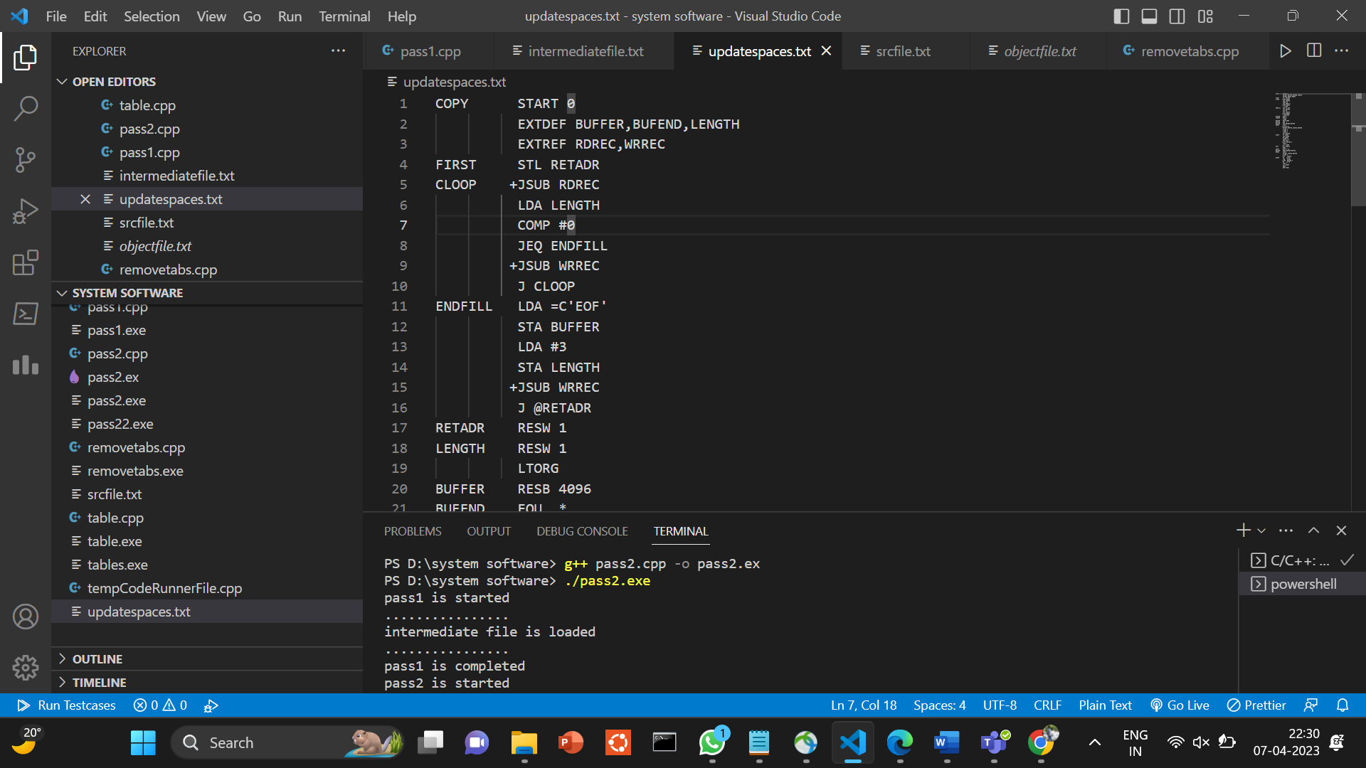

Intermediate file:(after running pass1 function intermediate file is generated)

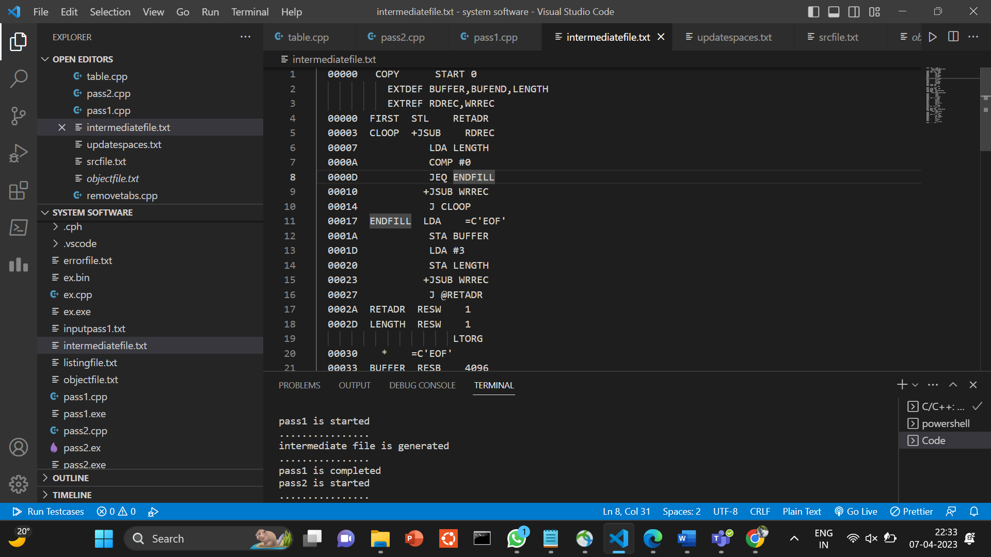  
  
  
  
Listing File:

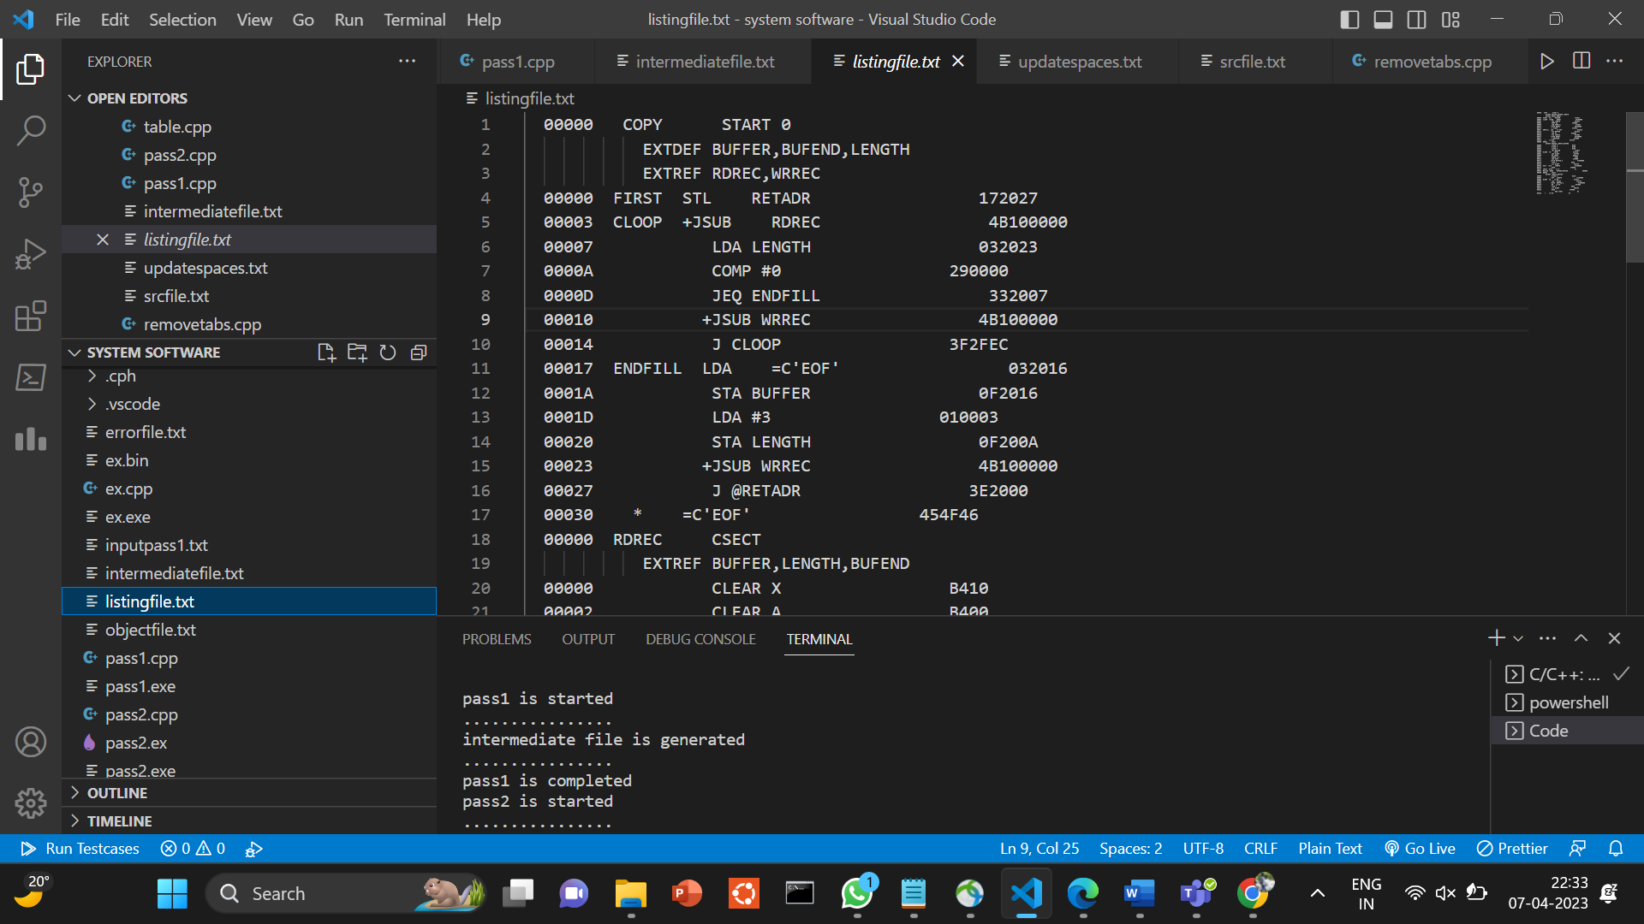

Object Program file

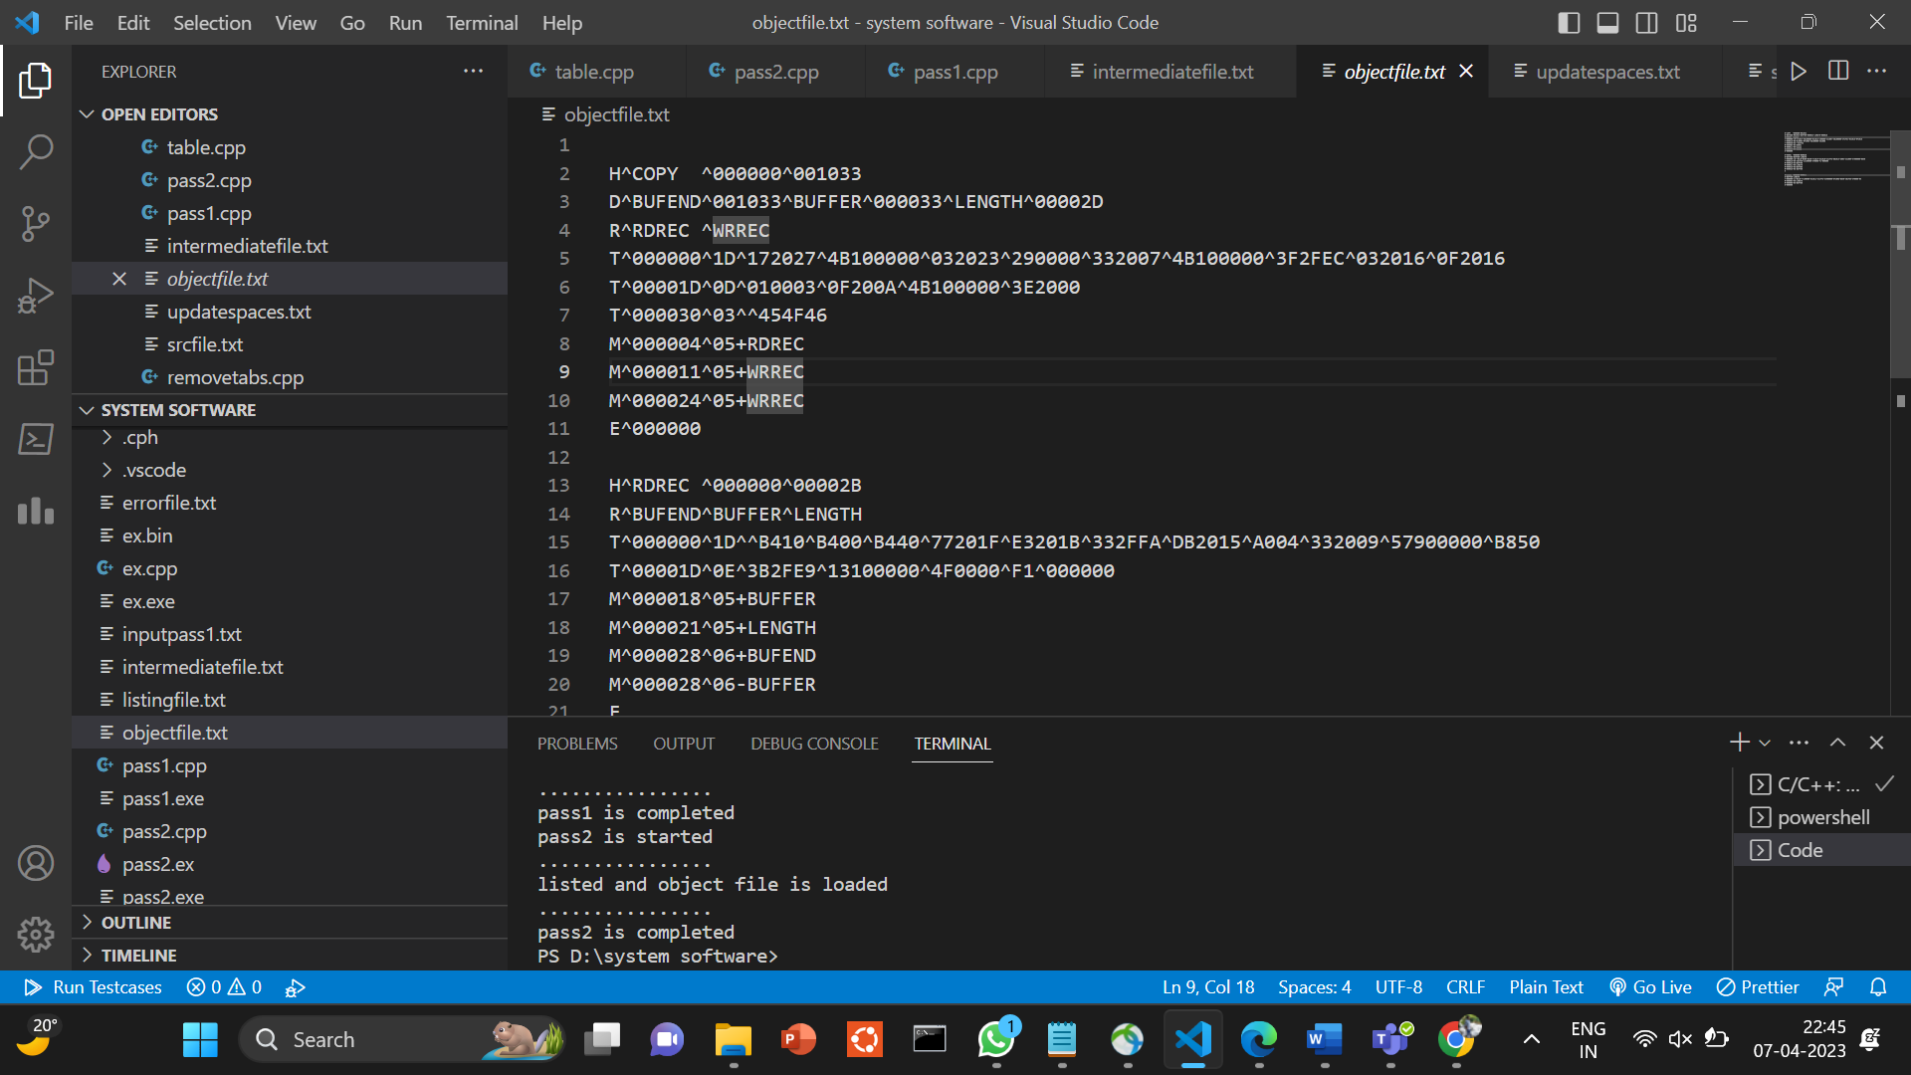  
  
  
  
  
Error file:it shows errors in the code(if any)

**table.cpp :**it contains all the data structures required to design the assembler It also contains definition of representation of many tables such as symboltable, opcodetable, etc :- using unordered_map(STL)

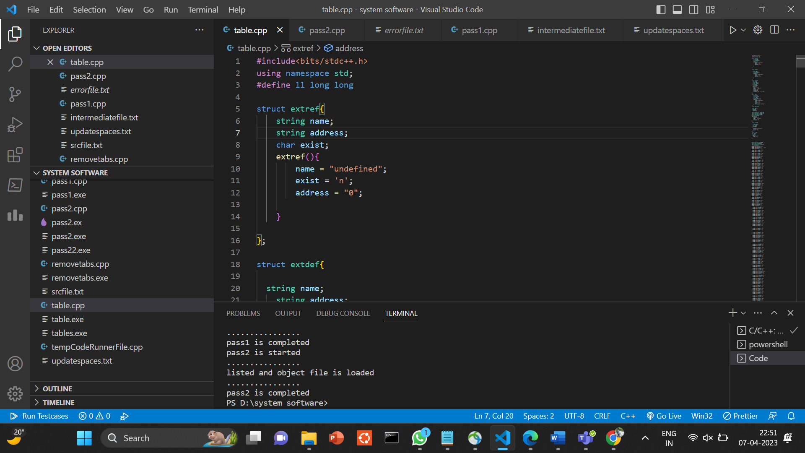

**removetabs.cpp:**this is for preprocessing the src file which I included in pass2.cpp file

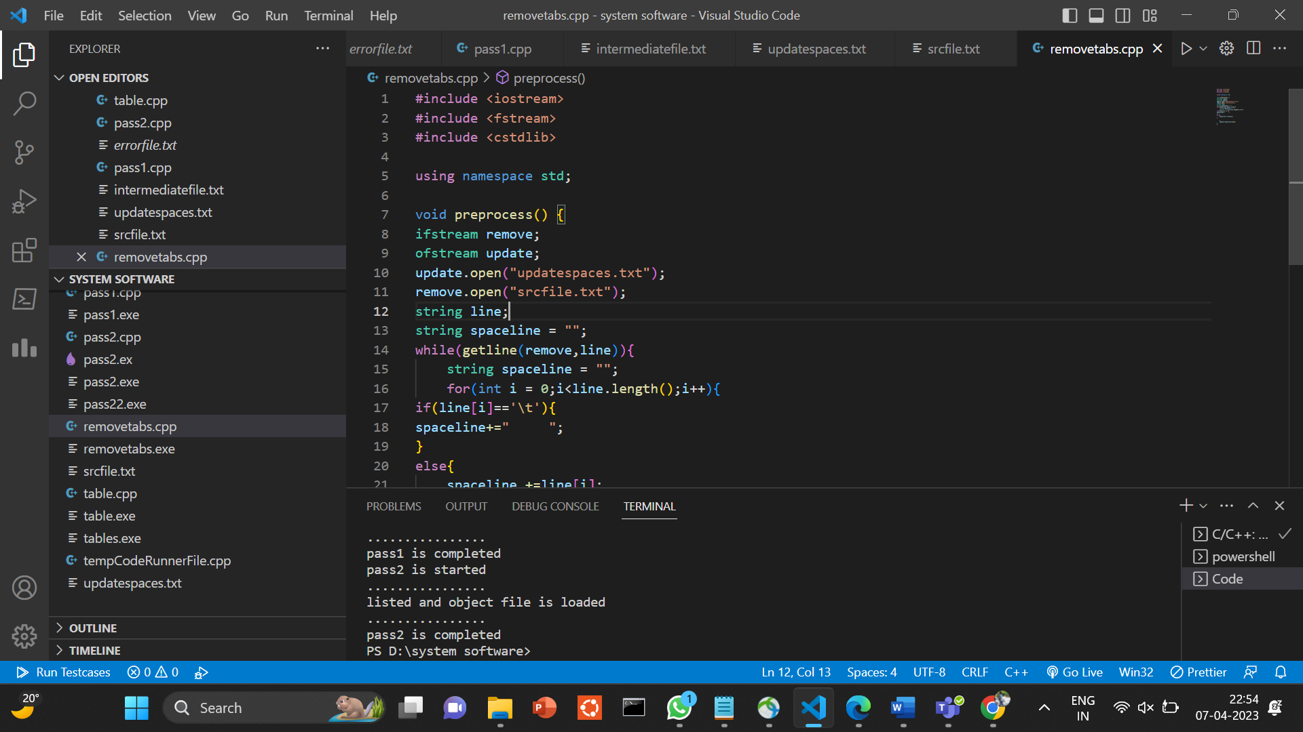

**IMPLEMENTATION TECH :**

I have implemented assembler using C++ programming language. I also have used many C++ libraries such as ifstream, ofstream to read input from a file and a write output in another file.